Description : This query evaluates which types of products (e.g., Laptops, Smartphones, Furniture) are most successful at closing sales at the touchpoint level.

Query :

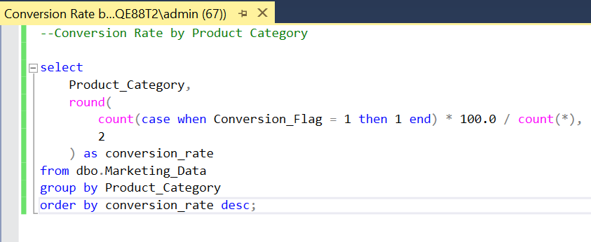

Solution :

